Web Frameworks
  - Report 1
  - Oleksandr Motoryhin
Treech is a web application made to create posts and share your thoughts in world wide web.
Currently I implemented the following functionality:
- Login
- Registration
- JWT token that is being saved in cookies
- Viewing posts
- Creating a post
- And delete a post if you own it

Github: https://github.com/sahar-bot/Threech
Render build (will take some time to load): https://threech.onrender.com/auth/registration

Instead of CommonJS type I’ve been using Module type of importing files or dependencies. Nothing aside from syntaxis changes. Can be changed in:
package.json
“type”: “module” / “commonjs”

Views
Currently in the project there are 3 views and 1 style CSS files, which are stored in public folder which prevents access to anything else than that.
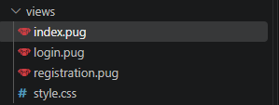
Login and registration pugs are mostly common html files written in pug + one check for variable error. Which will be given from the authController and display error message.
Index.pug has not only error check but also check for an object of posts and then handle it to show in a proper way. Also has been added modal form, which is just a form that appears or disappear, when click on allocated button + new Post.
Style was made just in CSS.
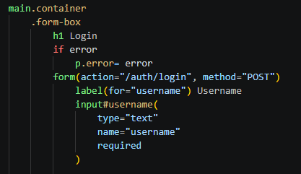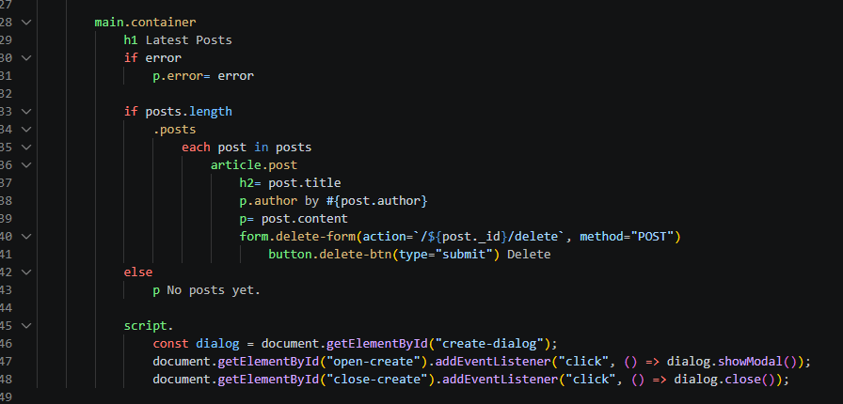

Controllers
Threech currently has 2 controllers: authController.js and postController.js
The first one handles the authentication process registration and login.
If looking in depths:
It can render for user login or registration pages, with allocated functions
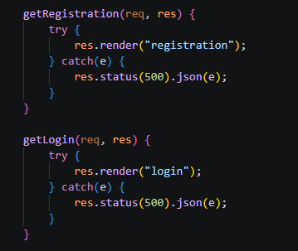
It can register a user into the system, by taking data from form (req.body) then using function from the model, which goes to database and check whether there is a user with such username, if so, controller renders registration page and send error parameter. After that function hashes password using bcrypt, saves user to the database and redirect user to login page.
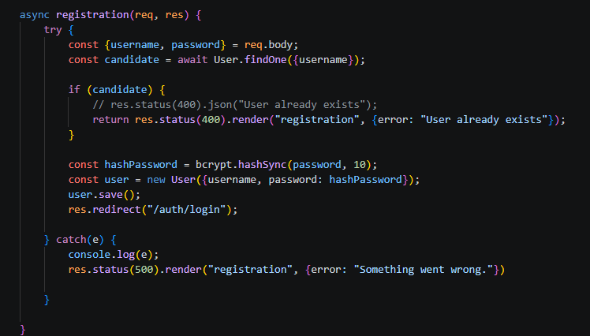
Login function a little bit more complicated, because for its normal work, there should be written two more function, one which will be used across all the web app. Mostly it works the same as registration function. It also gathers data from the from, then also uses findOne to check whether we have that user, if no -> render login page with bounded error variable.
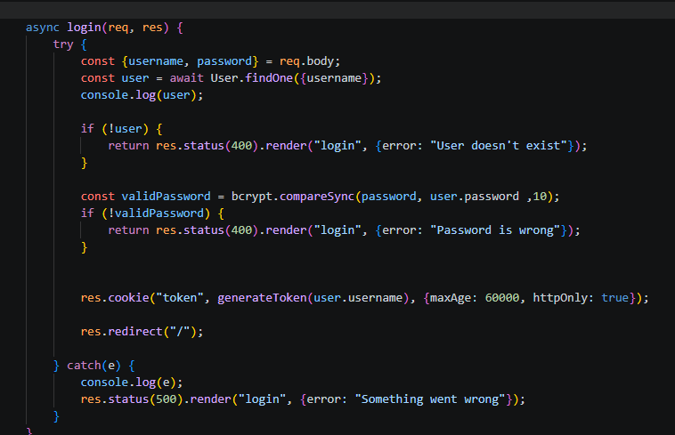

The next step for the controller is to generate a JWT token, which will be granting access to the web site pages, like “/” main page or any different that will be created. For this I’ve created middleware file in “utils” folder with 2 functions. The first one takes values from .env file to create a JWT token and hide our user’s username in it, then sends back to our controller and the controller saves this token in cookies with “token” key.
For this JWT token to work I have also created the second function in authMiddleware.js
Which verifies, does user (the one who’s trying to access) have token or not?
It extracts value of token from cookies, checks if it’s empty or not, redirecting user to login page or decodes JWT with value from our .env file and saves it in req.user, which we will be able to use from now on. Also, I should mention about next(). Because I will be using this function in router, it is very important to show our program that it can go to the following page, otherwise it will be waiting for eternity.
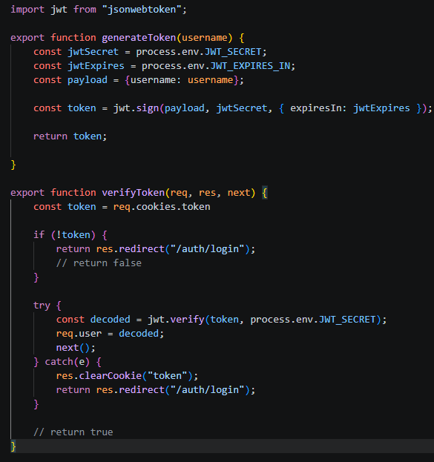

Now to the post controller.
Fairly simple. Just 3 functions.
getall() To render all posts on the web page.
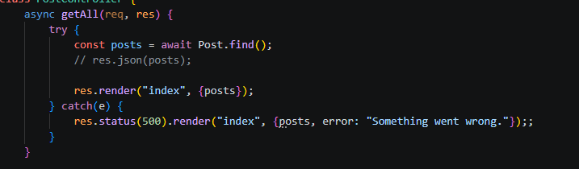
createPost(), which firstly saves all the posts in the variable, then extracts data from the form and creates a post.
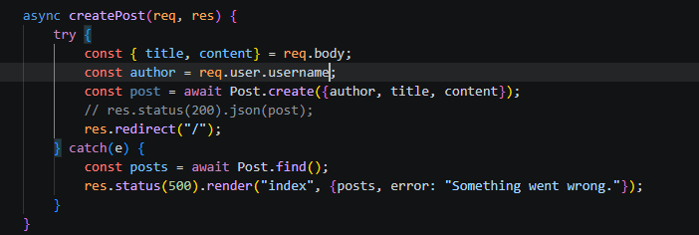
deletePost(), which firstly check if the post exists, then if the author of post is the user, who’s trying to delete it.
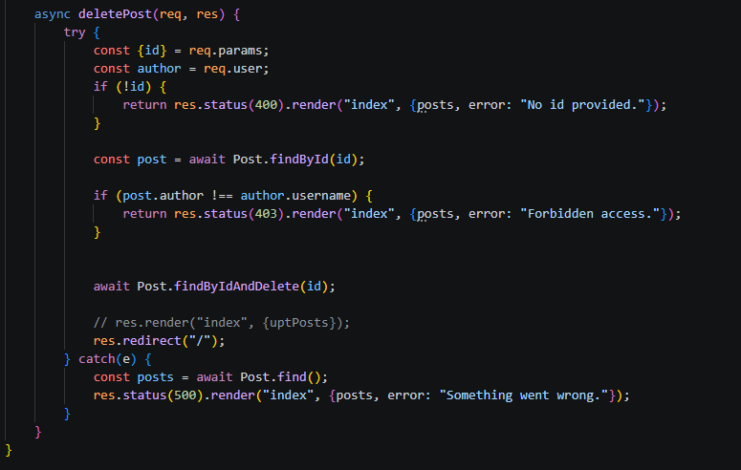

Routers
Threech has 2 routers. authRouter and postRouter. They just bind the functions from the controller and uses the middleware function I wrote to check for JWT token.
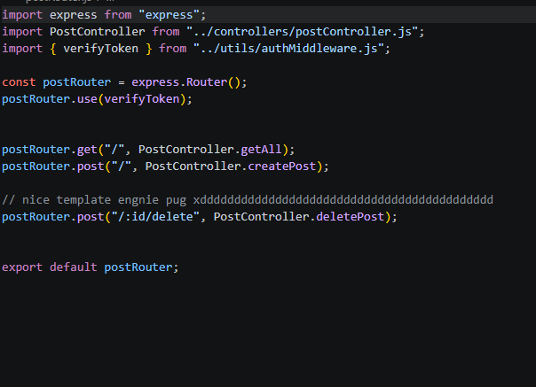
Also there is a workaround in postRouter delete route. Because for some reason you can’t assign DELETE method in pug form, I had to made it post, but with /delete in the end.

Models
2 Models, both describing how to save data in MongoDB
Post saves author, title and content.
User saves username and password.
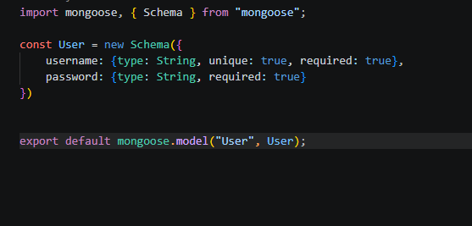
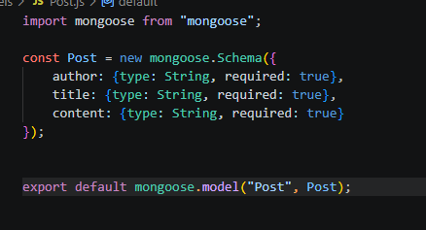

Sample of posts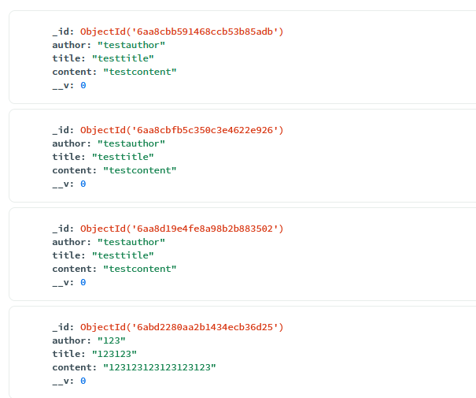
Sample of user
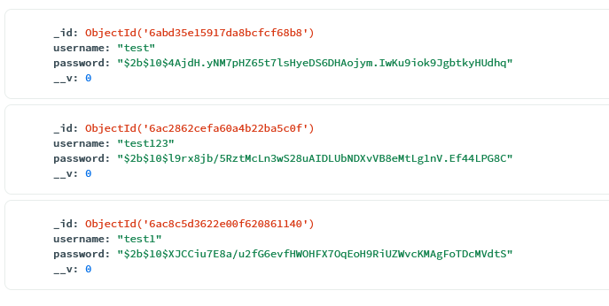

API
For the API testing I will be using Swagger and addon to it swagger-autogen. This library can create auto-generated documentation of all handles in your project and easily check each of them, also showing possible outcomes.
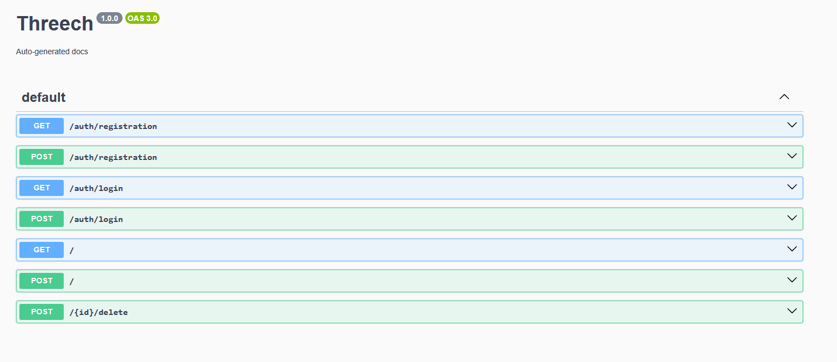

To connect it to the project I’ve installed 2 libraries swaggerui and swagger-autogen.
Firstly, I’ve created swaggerGenerator and pasted code from the official documentation.
https://swagger-autogen.github.io/docs/getting-started/advanced-usage
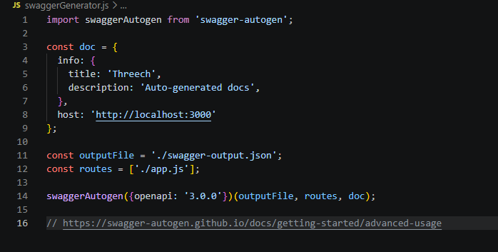

After that, ran the file with “node swaggerGenerator.js” and connected it to the app.js on the /docs route.
